National University of Computer and Emerging Sciences



Laboratory Manual

for

Computer Organization and Assembly Language Programming

(EL 213)

|  |  |
| --- | --- |
| Course Instructor | Ms. Tayyaba Waqar |
| Lab Instructor(s) | Mr. Umar Bashir  Mr. Muhammad Usman Khan |
| Section | G |
| Semester | Fall 2020 |

Department of Computer Science

FAST-NU, Lahore, Pakistan

## Objectives

After performing this lab, students shall be able to:

* Learn conditional and unconditional jumps.
* Be able to take decisions on what conditions suits where in code.
* Translate high language programs to assembly language.

**Exercise 1:**

Make three-word Type Arrays with 10 numbers each, add the corresponding elements of the three arrays and store them in a fourth array of type Word, starting at physical address 0x53332.

*Example:*

*Array 1 = 101, 200, 500,320,550, 632, 470, 747, 800, 600*

*Array 2 = 50, 99, 256, 230, 550, 663, 220, 55, 632, 32*

*Array 3 = 77, 23, 100, 221, 560, 621, 156, 254, 952, 221*

**Exercise 2:** Write an assembly program which finds if an array 'digits' is palindrome or not. The array ends on a -1. If the number in the array is palindrome, set bx to 1 and 0 otherwise.

**Palindrome**: A palindrome is a word, number, phrase, or other sequence of characters which reads the same backward as forward, such as madam or racecar or the number 10201.

**For example:**

|  |  |  |
| --- | --- | --- |
| If  digits: 1,1,2,1,1, -1  set bx=1 |  | If  digits: 1,2,2,2,-1  set bx=0 |

**Exercise 3:** Following is code to find intersection of two arrays

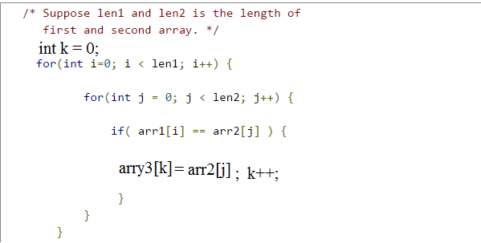

You have to write this code in assembly language

Store lengths of arrays in memory, all arrays should be of db type. Every number in arrays should between 0 and 255, i.e. unsigned.